### Why business analysis

Selecting transcript lines in this section will navigate to timestamp in the video

[- Are you working on an existing project and you hear the term business analysis used by your colleagues, but you're not sure what it is or why it matters? If you thought yes, you're not alone. There's a lot of confusion out there about what business analysis is. All of us make business decisions, therefore, all of us can benefit from learning more in this area. Hi, I'm Laura Paton. I've been working in business analysis for over 30 years. I've consulted with International Institute of Business Analysis and Project Management Institute where I've led the development efforts of some of the most widely used standards in this field today. In this course, I'll answer the question, what is business analysis by looking at it from three facets, the profession, the competencies, and business research. Afterward, you'll walk away empowered](https://www.linkedin.com/learning/what-is-business-analysis/why-business-analysis?contextUrn=urn%3Ali%3AlyndaLearningPath%3A62f3efdc498ecfe28bea2564)with the information you need to communicate [about what's needed to perform business analysis and have a clear expectation about this work within your project teams. Business analysis is a skillset all professionals can and should adopt. Developing analysis skills can provide many benefits, including bringing clarity to decision-making. Ready? Let's get started.](https://www.linkedin.com/learning/what-is-business-analysis/why-business-analysis?contextUrn=urn%3Ali%3AlyndaLearningPath%3A62f3efdc498ecfe28bea2564)

### What is business analysis?

Selecting transcript lines in this section will navigate to timestamp in the video

[- According to International Institute of Business Analysis or IIBA, business analysis is defined as the practice of enabling change in an enterprise by defining needs and recommending solutions that deliver value to stakeholders. That definition is a great start, but when I begin my classes by asking the question, what is business analysis, every time I receive a wide variety of responses. Some say it's a profession, some say it's a set of competencies, and others say it's the act of performing research. So which is it? Would it surprise you if I said that business analysis is actually all of these? It is. When we're talking about the profession of business analysis, we're referring to a vocation that consists of individuals who have experience helping organizations implement various forms of organizational change. Individuals who choose a profession in business analysis are called business analysts, but they can be called systems analysts or technical analyst, agile analyst, or a host of other job titles depending on their organization's preferences. While each of these job titles may introduce slight variations in job responsibilities, those who perform business analysis in this context consider themselves working in the business analysis profession, but not everyone who performs business analysis identifies as a business analyst or sees themselves working within the profession. Many individuals require strong business analysis skills and they may master a handful of business analysis tasks such as the ability to write proposals or business cases, but their job title requires the completion of tasks that are far outside the business analysis profession. This is where we will see people begin to define business analysis as a set of competencies, more so than a profession. Competencies such as facilitation, problem-solving, business and industry knowledge while critical skills to those who work within the business analysis profession are also skills we will see needed by a variety of roles outside the profession. And that brings us to our third way to think about business analysis, which is to view it as a research discipline. Those performing business research maybe analyzing the viability of a new business idea or whether a business should branch into a new geographic location. When performing business research, many techniques used by business analysts are useful to obtain information, analyze, and communicate research results. Next time business analysis is a part of your discussion in the work environment, assess whether the context of the conversation is about business analysis the profession, competencies,](https://www.linkedin.com/learning/what-is-business-analysis/what-is-business-analysis?autoSkip=true&contextUrn=urn%3Ali%3AlyndaLearningPath%3A62f3efdc498ecfe28bea2564&resume=false)or performing business research.

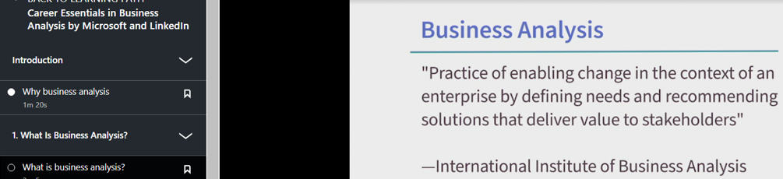

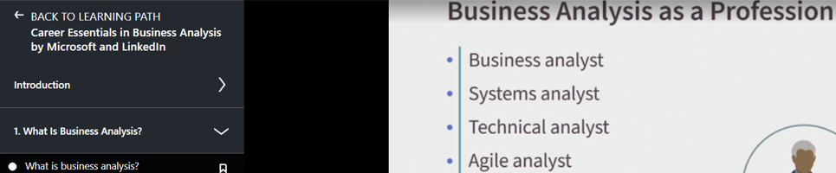

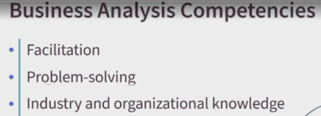

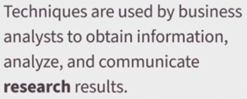

### Business analysis as a profession

Selecting transcript lines in this section will navigate to timestamp in the video

[- For as long as we've had business, we've had business analysis. It wasn't always referred to as business analysis, but understanding customer needs in order to offer something of value that customers wanted has always been the underpinning for running a successful organization. To appreciate the role this profession plays, let's take a step back and look at the history, starting in the 1960s. In the early '60s, there was the role of requirements engineer. Engineers responsible for the construction of buildings, roads, and bridges needed requirements to build from, and it was the requirements engineers who developed those requirements. Since these requirements supported engineering-focused solutions, early requirement-focused analysis roles were quite technical. But by the 1970s, the need broadened beyond writing requirements for engineering-based solutions. Mainframe computing placed computing power outside of academia and government and into the hands of business. There was a large demand for business software, and with that demand came the need for someone to develop business requirements. Systems analysts served as a bridge between business and technical teams, taking responsibility for communicating business needs and specifying system requirements to address them. System methods were gaining popularity to model data, data flows, and processing concepts. It was the systems analyst using these methods to communicate to developers what needed to be built. But by the 1980s, we were experienced a number of computing advancements. Improvements in storage and processing power drove demand for personal computers. Businesses still relied on their large mainframes, but there was a large push to develop software for desktop devices. A significant change was the graphical user interface, or GUI for short. Eliciting requirements for software applications now involved feature requirements, as well as focus on the user experience. We began to see users who are also evaluating an application on its front-end look and feel, as well as the back-end processing. And with this shift came a host of new analysis techniques and modeling conventions to capture user experience requirements, as well as the new title, the UI/UX analyst. But by the 1990s, it wasn't a question of whether you owned a computer as much as it was about how many devices you owned. The internet created demand for a variety of new software for browsing and running web applications. Mobile devices and wireless computing brought computing power off the desktop and into the hands of the mobile consumer. Now business analysis as a profession was on the rise, as software was everywhere. We needed effective business analysis to ensure the right products were being built and built correctly. In the 2000s, business analysis was formalized as a profession with its own body of knowledge and professional certification developed by International Institute of Business Analysis, or IIBA. While organizations continued to hire business analysts in increasing numbers, we also experienced the creation of a number of specialty roles in our profession. Where business analysis was used to identify process improvement opportunities, we now had business process analysts. And where business analysis was used to understand business data, to support data-driven business decisions, we had data analysts and business intelligence analysts. And that brings us to today. As business analysis continues to deliver value and branches out into the new context over time, we'll continue to see business analysis as an in-demand profession.](https://www.linkedin.com/learning/what-is-business-analysis/business-analysis-as-a-profession?contextUrn=urn%3Ali%3AlyndaLearningPath%3A62f3efdc498ecfe28bea2564&resume=false)

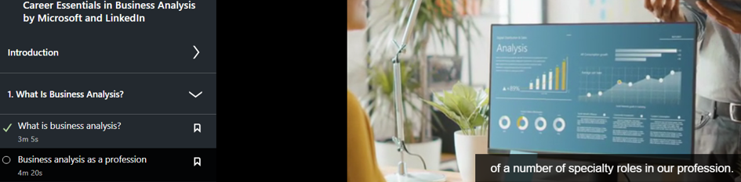

### Business analysis as a set of competencies

Selecting transcript lines in this section will navigate to timestamp in the video

[- Competencies pertain to a set of knowledge, skills and abilities used to enhance your effectiveness at performing a task. For example, I could train you on the semantics of writing good requirements, the task, but if you don't have strong communication skills, the competency, your ability to specify and communicate the requirements that you write will be negatively affected. Let's take a look at some of the core competencies that enable better performance of business analysis tasks. As I discuss each competency, think about the other professions that also benefit from these same competencies. At the top of my list is facilitation, which is your ability to lead a group of people through a discussion to achieve a set of objectives. Crystal is a business analyst who excels at facilitation. She often uses this competency when running requirement workshops, conducting a requirements walkthrough or moderating a discussion between stakeholders when they're unable to agree on a set of requirements. Crystal might simply move through the motions of completing her elicitation tasks but it's her ability to remain neutral, ensure audience participation and use strong meeting management skills, all of which come from the art of facilitation, the competency. That helps her complete her work more effectively. Problem-solving is the ability to research a problem to uncover the root cause of a situation. Business analysis professionals are tasked with defining and implementing solutions that address business problems. Take, for example, David, a senior systems analyst. He might choose to immediately run off and implement a quick solution to fix a problem, the task, or he can step back from the immediate situation, use his problem-solving skills, the competency, to ensure to perform sufficient research to uncover the true root cause of the problem. If David overlooks uncovering the root cause of the situation, he could be implementing a solution to address the wrong problem, which could result in making the situation worse and would definitely end up wasting a lot of time and money. If you have strong negotiation skills, you have the ability to lead a group of individuals who are having a difficult time reaching a mutually agreeable position and guide them to a decision. Lexi has been performing business analysis for several years. She has developed skills to lead challenging discussions calmly without taking sides. And she's quite good at removing the emotion from the decision-making process. When her stakeholders can't agree on a set of requirements, she could host a meeting, the task, and let the opposing sides passionately disagree until someone gives in but this will break down good working relationships. A better approach is for her to leverage her negotiation skills, the competency. Lexi can lead a discussion where she focuses the decision-makers on understanding the interests of each side, and together they can reach a mutually agreeable decision that meets shared interests. Lastly, industry and organizational knowledge are also important business analysis competencies. Industry knowledge pertains to knowledge about the industry your organization operates in. An organizational knowledge pertains to knowledge about how your enterprise functions, including its business model and customers. In business analysis, you can have little knowledge about the industry or organization and still develop requirements, the task. However, perform the same task by layering in strong knowledge about the industry and organization, the competency, and the analyst is more apt to ask more challenging questions, probe deeper, and overall being able to better maneuver the organizational culture when working with stakeholders. Which of these competencies do you notice in the business analyst you work with? Which of these competencies would you find most valuable at your organization right now?](https://www.linkedin.com/learning/what-is-business-analysis/business-analysis-as-a-set-of-competencies?autoSkip=true&contextUrn=urn%3Ali%3AlyndaLearningPath%3A62f3efdc498ecfe28bea2564&resume=false)

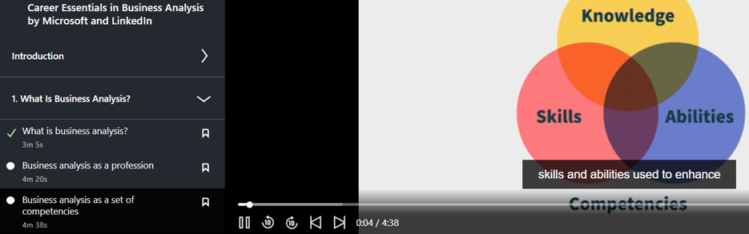







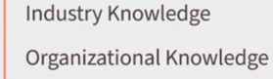

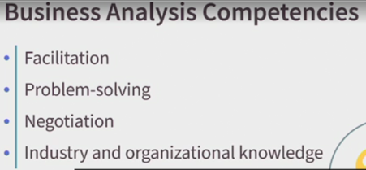

### Business analysis as a research discipline

Selecting transcript lines in this section will navigate to timestamp in the video

[- Business decisions can be made from personal preferences or gut feel. But this approach is much like a game of chance, like throwing darts at a dartboard. Business analysis, on the other hand, provides a structured approach to decision-making. It provides a framework to guide analysis efforts, producing the information that enables informed decision-making. When business decision makers, regardless of industry, pursue any type of organizational change, research is necessary to understand the change. This means clearly determining the purpose or driving factor for the change, how best to address or solution the change, and lastly, how to measure our success, once the change is implemented. Take, for example, company A, whose management team has made a decision to offer a new service. Before running off and building the service, it's important to understand what exactly the company is looking to offer, and why. Will this new service be provided in all regions or only in the local market? Is this service intended to gain new customers or retain existing ones? How will success be measured? Sasha is a senior business analyst assigned to help company A bring this new service to market. She has just wrapped up her first meeting with the sponsor, who has asked her to begin work immediately so the new service is available before the end of the year. Being experienced in business analysis, Sasha ensures proper research and analysis before jumping in too quickly with the solution. She takes time to define the situation, clear objectives and to analyze possible approaches for addressing the business' need. She was told the business is looking to grow their customer base. She has to feel facilitate discussions to uncover what percentage of new customers the company is expecting. Is it better to obtain a 20% increase with a $650,000 solution? Or a 15% increase with a lower risk option for $500,000? Sasha explores different solution options. Should company A build a new service from scratch? Partner with another company to provide the service? Or use a combination of in-house and external resources? What are the pros and cons of each option? A third-party service provider might make sense to meet the aggressive timelines, but it's her job to consider what if company A is not able to form an agreement with the vendor contractually? What if they lose some control being dependent on an outside company? What if the provider can only meet 60% of company A's requirements? Sasha must apply business analysis to conduct research and analyze discovered information. With the results of her analysis, she will be able to formulate a more targeted solution. Think about a time you stepped back to analyze a problem. Consider how you went about organizing your thoughts. Perhaps you thought through different factors causing the problem. You probed for information to better understand the situation. Were you able to eventually analyze solutions? In performing these steps, you were unknowingly performing the research aspects of business analysis.](https://www.linkedin.com/learning/what-is-business-analysis/business-analysis-as-a-research-discipline?autoSkip=true&contextUrn=urn%3Ali%3AlyndaLearningPath%3A62f3efdc498ecfe28bea2564&resume=false)

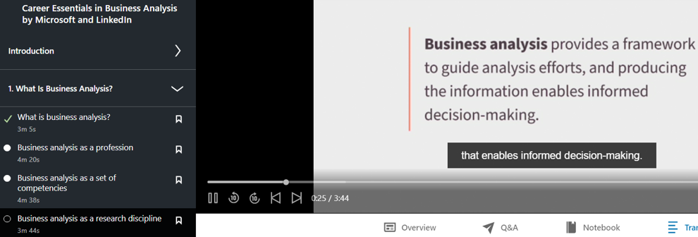

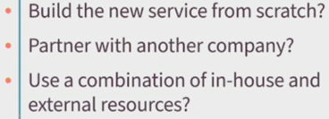

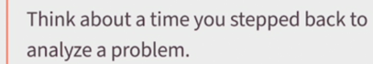

### The career path into business analysis

Selecting transcript lines in this section will navigate to timestamp in the video

[- Business analysis has seen amazing growth over the last decade as many organizations have experienced how effective analysis enables successful projects. As a result of this growth, professionals in all industries need to learn these necessary skills. The role of the business analyst has also caught the attention of many seasoned and young professionals. If you too have found an interest in the profession, you might be asking yourself, "How can I get started in this career?" Let's take a few minutes to explore some of the common career paths into this profession. At the top of my list is one of my favorites, which is transitioning into the business analysis role from an existing position within the business. Anyone who has experience working in a functional or operational support role, let's say in marketing, sales, or finance, for example, could pursue a career in business analysis. The strength that you bring with transitioning from the business is a strong understanding of how business operates, including how it services its customers. Having a strong understanding of what's important to customers or how existing processes or systems could be improved to provide more value is priceless when performing business analysis. Many times, those who transition into the profession from the business end up in an analysis role that supports the same business unit they transitioned from. This just makes sense since it eliminates having to spend months or even years training an existing analyst about a specific business unit. Another career path involves transitioning from a role in information technology, or IT. We often see individuals in product support roles, technical writers, or quality assurance positions interested in transitioning into business analysis. Professionals in these roles bring knowledge of existing products to the business analysis position. Product knowledge, like business knowledge, provides important context to frame business analysis activities. When new projects are sanctioned for the purpose of enhancing an existing product, it's nice to know your team has someone with extensive product knowledge to run questions past and learn from. Without strong product knowledge, a development team runs the risk of enhancing an existing product that results in its customers or users being less satisfied with the new product version than the old. Any role that can provide product knowledge is an ideal candidate for a business analysis position. But what happens if you're new to the job market? What if you're just starting off your profession and you have neither strong business or product knowledge? Does this make a career and business analysis unattainable? Absolutely not. Your career path into business analysis can occur directly after graduation. Young professionals who possess a strong passion for problem-solving, research, and analysis make strong entry-level candidates. Senior analysts often need extra support, especially when projects are large or complex. Entry level analysts are often paired to assist senior analysts, which is perfect to help you provide value to a project team while developing your skills on the job. In short, your path into this field can start almost anywhere, whether business, IT, or fresh out of school. Lastly, remember, while these formalized roles do exist, the bigger movement to date is around business analysis skills. All of us make business decisions. Therefore, all of us can benefit from learning more in this area. It's been a pleasure having you as part of this course. If you're interested in learning more, check out another LinkedIn Learning course, Business Analysis Foundations by Greta Blash. You could also visit iiba.org, International Institute of Business Analysis, and pmi.org, Project Management Institute. Both are organizations that offer helpful publications and certifications. Thank you for watching. I certainly hope you're now better equipped to answer the question: What is business analysis?](https://www.linkedin.com/learning/what-is-business-analysis/the-career-path-into-business-analysis?contextUrn=urn%3Ali%3AlyndaLearningPath%3A62f3efdc498ecfe28bea2564&resume=false)

